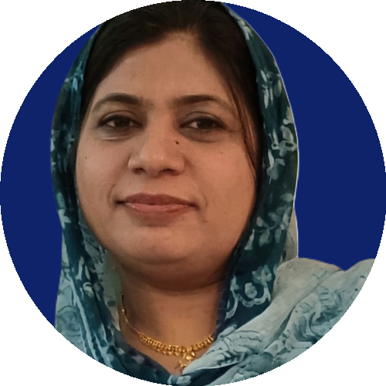
SADAF FARZANA
Computer Teacher | Computer Operator | Career Guidance Officer
☎ 0340-6676662 | ✉ addiayyan32@gmail.com
PROFESSIONAL PROFILE
Dedicated education professional with 20 years of experience as a Computer Teacher, Computer Operator, and Career Guidance Officer at the Punjab Vocational Training Institute, Kotmomin. Skilled in delivering computer education, managing office computer operations, and providing career counseling to students. Strong command of all essential computer skills required in a professional office environment.
WORK EXPERIENCE
Computer Teacher / Computer Operator / Career Guidance Officer
Punjab Vocational Training Institute, Kotmomin — 20 Years
- Taught computer courses and practical skills to students of varying levels.
- Managed daily computer operations, office documentation, and record-keeping.
- Provided career guidance and counseling to students for skill development and job placement.
- Maintained and supported institute's computer systems and office software needs.
EDUCATION & QUALIFICATIONS
- MA (Education) — M.Ed
- Unersity of Sargodha : 2015. 2.4
- MA — Political Science: Unersity of Sargodha : 2010. 2.8

- BLIS — Bachelor of Library and Information Science: AIOU Islamabad : 76% 2005
- FA (Intermediate): BISE Sargodha: 64 % 2003
- Matriculation: Bise Sargodha : 2009: 54 %
- Computer Operator Certificate Punjab Vocational Council lahre
SKILLS
- Proficient in all computer skills required for professional office work (MS Office, data entry, office software, internet & email correspondence).
- Computer teaching and training
- Career counseling and guidance
- Office administration and record management
LANGUAGES
Urdu, English, Punjabi

